

Letham Early Learning and Childcare

## **Session**

## **2024 – 2025**

Letham PS Nursery Class

Forth Drive

Craigshill

# EH54 5LT

Telephone: 01506 280676

Email: [wlletham-ps@westlothian.org.uk](mailto:wlletham-ps@westlothian.org.uk)

Please follow us on Twitter for updates…

Twitter: <https://twitter.com/PsLethamN>

**Welcome**

Welcome to Letham Early Learning and Childcare! This pack contains information about your child’s time in Nursery. Please read it carefully and keep it in a safe place for future reference. We hope that you find it useful and that it provides you with all the information you need before starting with us soon. If you require any further information, please contact us by email or telephone and we will be happy to help you.

We hope you and your child will find coming to Letham Nursery a positive and exciting experience. We look forward to meeting you soon!



**Head Teacher:** Mrs A Downie

**Principal Teacher**: Mrs C Raeburn

**ELC Area Support Manager**: Mrs D Young

**Early Years Officers**: Miss J White, Miss S McAlpine & Mrs L Harris

**Early Years Practitioner:** Miss J Cecil, Mrs L Burke, Miss C Hudson,

Ms H Rae, Ms E Morrison, Miss J Shepherd, Miss S Forrester, Miss A McFarlane, Miss S Bayliss, Miss V Gallagher & Mrs K O’Brien

**Pupil Support Workers**: Miss S Smith, Miss L Nicholls & Miss M Cheyne

**Nursery Hours**

Letham Early Learning & Childcare offers various hours & sessions.

These are as follows:

* AM (morning) Session: Monday-Thursday - 7.47am-12.30pm

Friday – 8.00am-11.57am

* PM (afternoon) Session: Monday-Thursday - 12.30pm-18.14pm
* Full day Sessions: Monday-Thursday (2 days) - 8.00am-18.00pm

Additional short sessions for full day children are: AM - 8.00am-11.20am,

PM - 12.45pm-16.05pm.

These hours/sessions depend on what your child has been allocated from Pupil Placement. Parents are free to collect their child at any time and drop off/collection times vary on individual needs.

Early collections (for appointments or events) should be mentioned to a member of staff when dropping your child off.

The setting is closed for two weeks over the Christmas period and on Good Friday & Easter Monday and in May for a bank holiday. Therefore, the service is available over 50 weeks of the year.

Holidays can be taken at any time throughout the year, but we request that parents/ carers inform a member of staff of **ALL** absences in order to comply with our ‘Safe Arrivals Policy’.

# **Our Vision and Values**

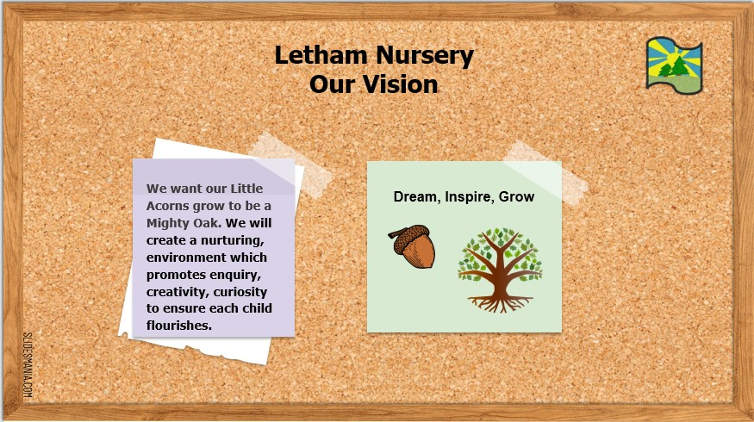

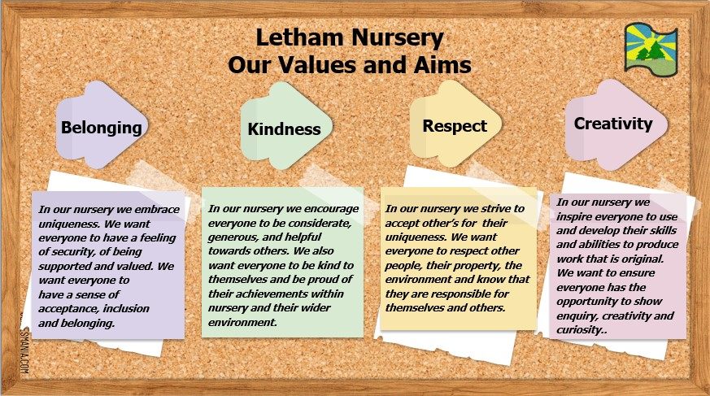

**Our Curriculum Rationale**

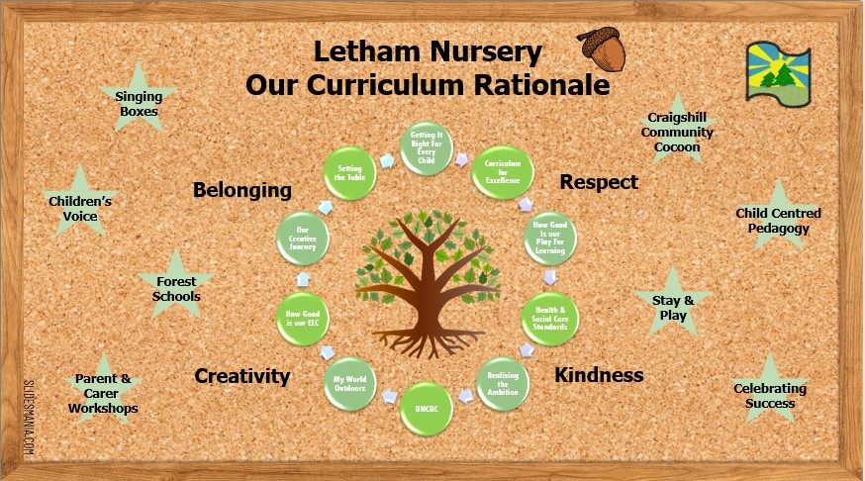

**Arrivals and Collections at Letham Early Years Setting**

**Arrivals**

All children arriving at Letham ELC should come to the main ELC entrance through the school playground, where you will be greeted by staff in the cloakroom.

**Collections**

All children will be picked up through the same entrance as arrival.

Please note no children’s bikes or scooters should be left at the setting due to space and for health and safety reasons.

**Please note: if you are dropping off/collecting between 9am&12pm or 12.45-3.15pm please use the nursery garden gate as the playground is locked between these times.**

A **password** may be required if we have not met the person collecting your child. This password will be on your child’s Personal Plan and will be put in place at the point of enrolment before your child starts.

*Children may only be dropped off and collected by a person aged over 16 years of age. Please notify staff of this change.*

**Everything I need to start nursery:**

* Appropriate, comfortable and simple clothes which are easily washed.
* Warm clothing such as jackets, wellies, gloves and hats for the colder weather.
* Clothes/belongings that are clearly labelled with my name.
* Spare clothes in nursery bag (If I need changed at any time throughout the day).
* Separate waterproof trousers and jackets **or** all-in ones, to help keep clothing and jackets clean and dry.
* Indoor shoes (black gym shoes or trainers).
* Sunhat and Suncream.
* A packed lunch (if you don’t want hot lunches).

Toilet Accidents do happen and your child may need to be changed out of wet or soiled clothes in Nursery. If this is necessary, staff follow our changing procedures & guidance.

We encourage children to be independent in changing where possible. All changes are logged explaining why and when your child was changed and you will be asked to sign this on collection.

Our nursery polo shirts, T-shirts and sweatshirts can be ordered and purchased online from ‘Borders Embroideries’ if you wish to buy uniform. This is optional. <https://www.border-embroideries.co.uk/search/letham%20nursery>.

**Settling Sessions:**

Each child will be supported to settle into nursery with help from their Parent/Carer and staff members. Nursery settling sessions can vary depending on how each individual child copes with their settles.

Their first settling session is normally around 1/2 hours where a parent/carer will stay with them for the duration of this first visit.

*Some children will settle quicker than others - there are various reasons for this. Each situation is different and the staff will offer individual strategies for settling children.*

**Key Workers:**

Each child will be allocated a Key Worker who has responsibility for a small group of children. Groups are named by colour and based on children’s days of attendance.

Key groups enable staff to monitor and assess the development and progress of each child at nursery. Key workers will be responsible for adding observations to your child’s Seesaw journal, carrying out parent consultations and updating the personal plan/support plan.

**Personal Plans & Support Plans:**

Every child attending the nursery will have a personal plan which sets out how the child’s health, welfare and safety needs are to be met. This is a legal require in line with The Social Care and Social Work Improvement Scotland (Requirements for Care Services) Regulations 2011.

The personal plan is included in the welcome pack to be completed by parents/carers when a child starts nursery. Staff are available to support the completion of this document.

The personal plan will be reviewed with your child’s key worker every 3/6 months.

### **Seesaw:**

Throughout the year staff build up a profile of your child’s achievements, development and next steps. This is done using Seesaw which is a secure online journal where children can document and reflect on learning. Once you are set up, you and your child are able to access this at home and add photo/videos/drawings etc. In addition to Seesaw, children will receive a written report in June prior to their transition into Primary 1. There are also designated opportunities across the year for all parents/carers to discuss their child’s progress and experiences with their child’s key worker at a parent consultation.

Ante-Pre School children should have a minimum of 3 observations per term and Pre-School children should have a minimum of 6 observations per term. This is not updated daily and staff will work hard to update these regularly to document your child’s learning journey in nursery.

**Big Bedtime Read**

Sharing books and listening to stories is an activity that can support your child’s language and literacy development. Your child will be provided each week with a bag of books to share with you at home. Each child will be encouraged to return their book bag at the beginning of each week and select a new pack throughout the week to take home. They will be encouraged to share details and talk about the books that they have read at home. Parents will receive a letter about the Big Bedtime Read as soon as we have launched this and before we send books out.

**Absences:**

Should your child be unable to attend Nursery due to an illness please ensure that you contact the setting before 9.30am or 1.30pm on each day that your child is absent. We are required to contact any parent/carer whose child is absent without any explanation. This will happen on the first day of absence. If no contact is made with the Nursery to state the reason for absence then twe will follow the West Lothian Council reporting Unexplained Absence Policy.

Although nursery education is not compulsory, there can be little progress made if your child is persistently absent and absences can also be unsettling for your child.

**Illness:**

If your child is unwell, please keep them at home until they have fully recovered. This is particularly important in the case of sickness and/or diarrhoea when your child must not return until 48 hours after the symptoms have ceased.If you are unsure how long your child should be kept off Nursery please call and seek advice from staff.

**Bumps/Accidents:**

Bumps and bruises are a common occurrence with young children. If your child has a bump or accident during their time in Nursery you will be given an accident form which will give you details of what has happened and how the staff dealt with it. If it is a head/facial injury staff will call you to advise you there has been an accident. Staff will follow WLC First Aid procedures and may contact you if they feel the injury is more serious and medical advice should be sought from your GP surgery.

**Medication:**

The "Procedures for the Management of Pupils with Healthcare Needs" is a West Lothian Council guide that provides a structure to assist all learning establishments in meeting the healthcare needs of children the measures detailed in the procedures enable practitioners to efficiently support children with healthcare requirements. Practitioners will work continually with families to ensure that children’s health conditions and care requirements are clearly and accurately recorded and that there is full knowledge and understanding of the medication and care interventions required whilst your child is in nursery.

<https://www.westlothian.gov.uk/article/68000/Procedures-for-the-Management-of-Pupils-with-Healthcare-Needs>

In the instance that your child needs to be given medication during nursery hours, please speak with a member of staff who will help you complete the relevant paperwork. No medication should be kept in your child’s nursery bag at any point.

**Allergies and Intolerances**

If your child has any allergies, food intolerances or specific foods that they do not eat, this should be included in their personal plan and made known to your child’s key worker and/or the Early Years Officer. We are happy to discuss snack menus and to amend these to suit the needs of the children. The snack menu will be on display in the cloakroom along with a list of allergens which relate to that menu. We will also ask you for a note from your GP of your child’s allergy to allow our kitchen staff to cater for your child’s dietary needs.

**Applying Suncream:**

Parents/Careers must provide an unopened bottle of suncream at the start of Nursery term which staff will label and store within nursery. This will be kept for a year and then you will be asked to provide a new bottle. You will complete a suncream permission section at the back of your child’s Personal Plan.

This ensures staff have access to a bottle of suncream for each child, with a completed form allowing it to be applied. Without either of these your child may be restricted in their play outdoors especially in warmer weather. Parents will be asked to apply sun ream prior to your child coming into nursery on sunny days.

*Staff cannot apply another child’s suncream to your child or apply suncream without permission.*

**Healthy snacks & lunches**

Letham ELC is ‘Health Promoting’. In line with local and national guidance, we provide a breakfast, morning snack, hot lunches, PM snack and a late snack.

There are various healthy snacks on offer throughout the day at nursery which

follow the NHS Setting the Table Guidance. Children will also have access to a

drinking station at all times to keep them hydrated. Our snack menus follow a

There are various healthy snacks on offer throughout the day at nursery which follow the NHS Setting the Table Guidance. Children will also have access to water at any point throughout the day. Our snack menus follow a rota and will be displayed in the cloakroom and the notice board outside the nursery.

All children are entitled to a school lunch while at nursery. A copy of the lunch menu is in your child’s induction pack and can be found on the West Lothian Council website. This is optional and you are still able to provide your child's own packed lunch if you wish. You can find information on healthy choices for packed lunch on the Parent Club website:

<https://www.parentclub.scot/>

**If your child has specific dietary requirements and/or allergies identified by his/her GP/Consultant please let us know and we will ensure these are catered for when preparing our menus.**

It’s important to keep staff informed and up to date of any changes to this information.

Full day & Morning children will have a rolling lunch beginning at 11.30am and are allocated around 30 minutes. The afternoon children will be offered their lunch at 12.30pm until 13.00pm. If you choose to provide a packed lunch box for your child, this should be stored in our packed lunch fridge located within the ‘Craigshill Café’ room. Your child’s lunch box should also be labelled with their name.

*Due to allergies within the nursery/school please note* ***no nut products*** *are allowed and there is a ban on chocolate spread.*

*Grapes and cherry tomatoes should be cut in half (length ways) to avoid choking hazards. Children will not be able to eat them if they are not cut correctly.*

### **Positive Attitudes and Relationships**

At Letham ELC, we work closely with the children to develop a positive attitude and community spirit. We understand that children communicate and express their needs and emotions in a variety of ways, dependant on their experiences and individual stage of development, as identified in Realising the Ambition (Being Me). <https://education.gov.scot/media/3bjpr3wa/realisingtheambition.pdf>

To support a common approach to developing positive attitudes and relationships, we have developed a ‘Promoting Positive Relationships’ policy which embraces the values underpinning the Realising the Ambition document *(Scot Gov),* Getting It Right For Every Child *(Scot Gov),* and our Letham Community rules - **‘Ready – Respect – Safe’.**

### **What your child will experience and learn at Letham ELC**

Within our ELC setting your child will find a welcoming, nurturing, positive space, where all children are included and treated with respect. Our environments are constantly reviewed and developed to provide opportunities for children to acquire skills, knowledge and understanding. We offer a child centred approach which acknowledges children’s views and interests, actively involving them in decision making and planning, and we provide planned spaces and resources in which children can play and learn and develop their present and future potential.

At Letham ELC we build on what your child already knows, increasing and expanding that knowledge by offering a variety of stimulating activities through which they can develop a breadth of understanding.

Your child will have opportunities to explore different activities and in doing so they will learn to become independent and confident, learn to share and become aware of others. They will be encouraged and challenged to investigate and discover, applying what they have learned, across all areas of the curriculum. The development of early literacy and numeracy skills are fostered in our setting, with a multitude of opportunities and activities provided to develop these skills both indoors and out. Children will predominantly lead their own learning however staff are available in all areas of the setting to provide extension and support when required.

**Moving on from Nursery/Transitions**

Children who attend nursery can do so for up to two years and during this time we are preparing them for transition to school. Transition is ongoing and we value our part within the school community. We use many areas of the school building such as the lunch hall, gym hall, playground and library.

**Infection Control**

Help and support is offered to children to promote independence in good hand hygiene practices. We actively promote good hand hygiene through frequent handwashing on arrival at nursery, before and after mealtimes and on using the toilet. We encourage children to avoid touching their faces including mouth, eyes and nose, using a tissue to cough or sneeze, and use bins that are emptied regularly for tissue waste. To minimise the spread of infection we follow Public Health Scotland Infection Prevention and Control guidelines.

<https://hpspubsrepo.blob.core.windows.net/hps-website/nss/2448/documents/1_infection-prevention-control-childcare-2018-05.pdf>

**Sleep and Rest Time**

In addition to active play and learning experiences our playroom offers your child warm and cosy spaces for quiet times, rest or sleep. Your child can choose when to access these areas. If you feel your child will need a period of rest during the nursery day please discuss with the staff in the nursery. This will be reflected in your child’s personal plan.

### **Child Protection**

“It’s Everyone’s Job to Make Sure I’m Alright” – This document produced by the Scottish Government in 2002 reinforces that all children and young people in Scotland have the right to be cared for and protected from harm and we (staff, parents, carers, community) have an important role in preventing the abuse and neglect of children.

All members of staff in the Early Years Centre have been trained in West Lothian Council’s Child Protection procedures. It is our job to follow them when there is concern, ensuring that the protection and the wellbeing of our children is at the heart of all considerations and decisions taken. Posters outlining Child Protection procedures for staff are displayed in prominent places within the Centre. The Designated Members of Staff for Child Protection in our Centre is: Mrs Downie (Head teacher), Mrs Raeburn (Principal Teacher), Miss Young (ELC area support manager), Miss McAlpine, Miss White & Mrs Harris (EYO’s).

Our children have regular opportunities to discuss personal safety issues as part of their curricular experiences and are encouraged to speak to the Nursery staff if they have any worries or concerns.

Remember “It’s Everyone’s Job to Make Sure I’m Alright” and if you have concerns about any child please contact:

Social Work Livingston 01506 282252

Police Public Protection Unit Livingston 01506 282255

### **Customer Care**

All staff in the Nursery are committed to providing high quality experiences for all our children and their families and want the very best for all users of the setting.

If you do have a complaint regarding any service we provide in the Nursery please speak to any member of the staff in the first instance. If you require to take your concerns further please contact the Head Teacher.

You can also contact;

Customer Care

West Lothian Civic Centre

Howden South Road,

Livingston,

EH54 6FF

Telephone: 01506 281255

and/or

Care Inspectorate

Compass House

11 Riverside Drive

Dundee

DD1 4NlY

Telephone: 0845 9527

Please remember that our aim is to promote good communication and foster good relationships between all our stakeholders. We hope that you find the content of this handbook helpful. If there is anything you are concerned about or have any unanswered questions please do not hesitate to speak to a member of staff in the Nursery.

**We look forward to welcoming you and your child to Letham ELC**